Assignment 2(DUE DATE: 18-12-23)
- Illustrate the BFS procedure on the following graph
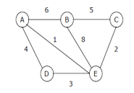
- Find the DFS of the following graph
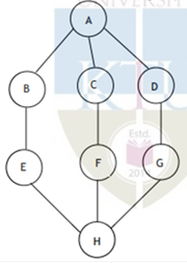
- Show all the passes using insertion sort for the following list 54,26,93,17,77,31,44,55,20
- Given the following list of numbers: [21, 1, 26, 45, 29, 28, 2] find the output obtained after each recursive call of merge sort algorithm
- Trace the working of the quick sort on the following input 38, 8, 0, 28, 45, -13, 89, 66, 42
- Using the heap sort algorithm sort the input file [35 15 40 1 60]
- Illustrate heap sort algorithm using the following list 82, 90, 10, 12, 15, 77, 55, 23
- Construct a max heap with the following set of numbers entered sequentially. 10, 5, 14, 7, 12, 18, 15, 13

